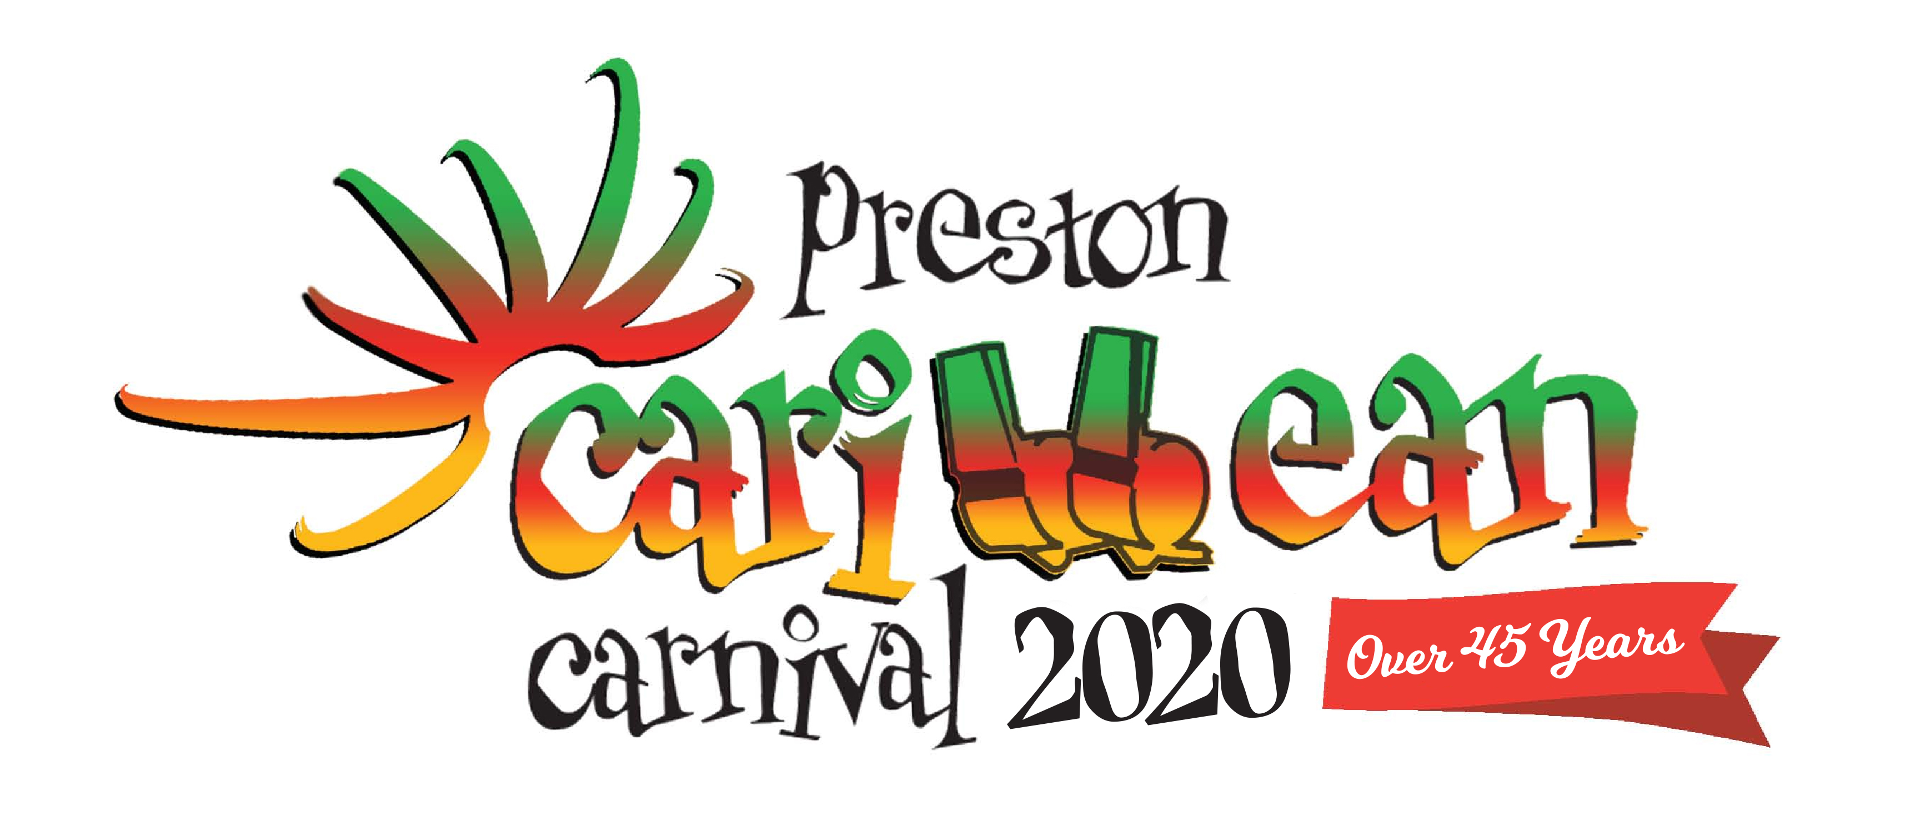
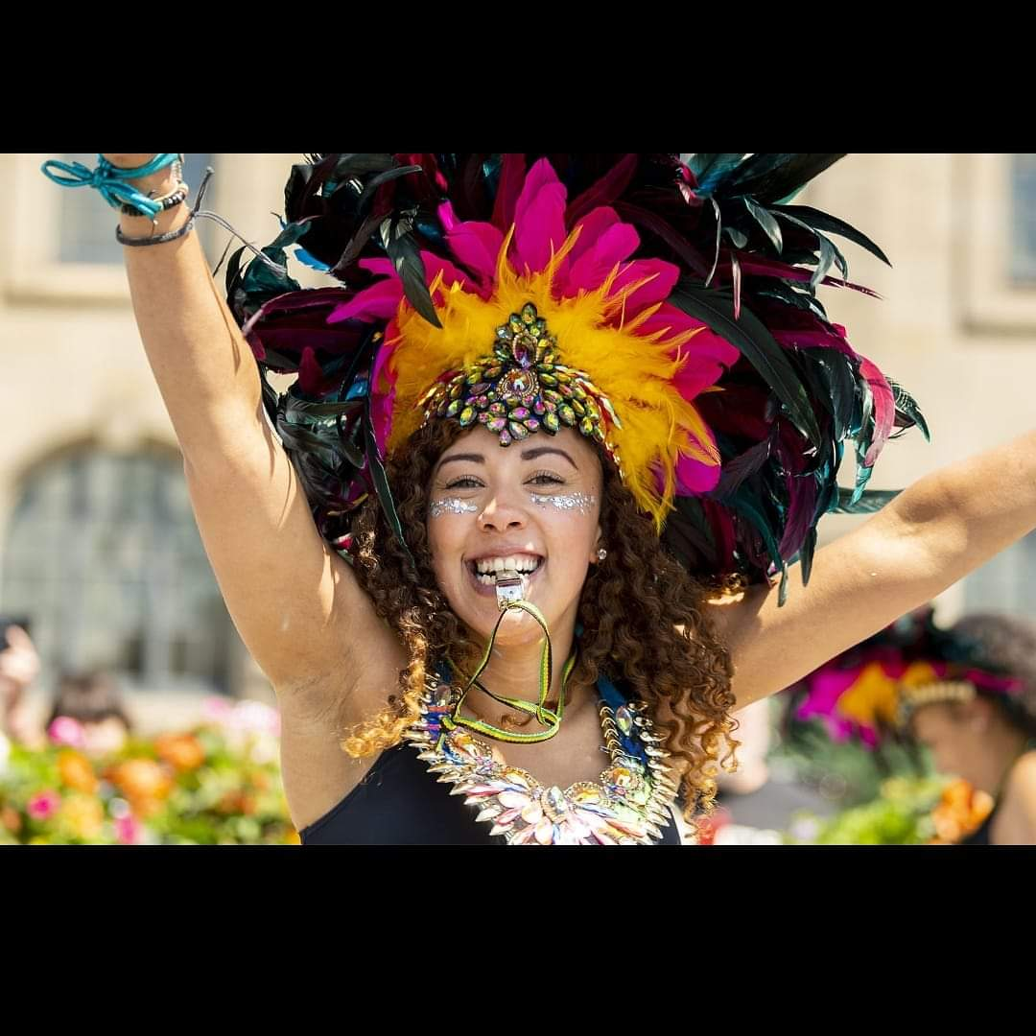
2020 Sponsorship Opportunities for The Preston Caribbean Carnival

The 2020 Preston Caribbean Carnival celebrates all things Caribbean, cultural and artistic in the City of Preston. Previous years have attracted over 30,000 visitors joining in the fun. With award winning costumes, vibrant music with steel pans, delicious Caribbean foods & drinks and inclusive family entertainment; it is the best party that you will be invited to in Preston this year!

When & Where?
The excitement begins from Midday on Saturday 6 June 2020 with our ‘One Park Living Legends’ Festival with music from the Caribbean islands. Channel One are one of the best Sound Systems in Europe and they are coming to perform. We are introducing a Main stage offering the best in reggae artists Little Roy, Tippa Irie & JahFet along with International Grammy nominated reggae superstar Luciano are due to hit our stage and entertain the locals. This all takes place on Moor Park in Preston.

The Carnival procession starts at midday, this year our theme is ‘As the Romans do’ and we dance & wine along the streets of Preston, showing beautiful Roman themed costumes and large King & Queen pieces, your business could be adverting on one of our decorated trucks to an audience of 20,000 on the road, as we make our way to the park, where the show continues.

Caribbean entertainers, steel bands and our local & visiting troupes will perform on a main stage from12.30pm till 7.30 pm on the Sunday along with a DJ. There will be stalls, Caribbean foods, jerk chicken, curried goat & roti’s concessions and other family entertainment too so it is an event not to be missed, come and be one of the crowd.

How Your Business Can Benefit?
This is a family event in Preston for 2020, you can get involved and reap the benefits of exposure to a happy local crowd too….
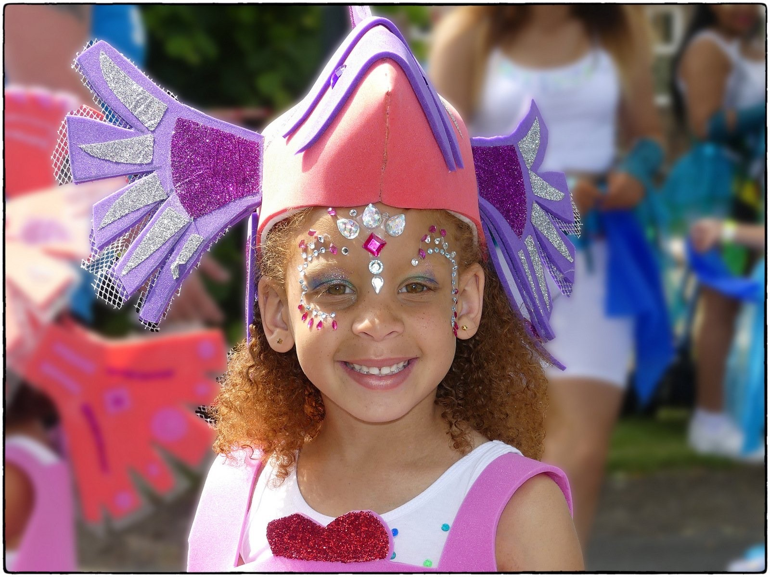

We have the following sponsorship packages for 2020 available, which are likely to be snapped up quickly. Don’t miss out.

2020 Preston Caribbean Carnival Sponsorship Packages
Sponsor Level | Price
Platinum – 1 only  - Main stage sponsorship and branding of your choice  - Prominent website position for your logo and link to your website  - 6 x Tickets for free entry to carnival park event on Sunday 7 June 2020  - 6 x Company members given free entry to ‘One Park’ Living Legends concert on Saturday 6 June 2020 (worth £120)  - Your logo on all promotional material created  - Social media links to website inc. Facebook & Twitter  - 2 Advertising banners supplied and installed by Carnival (worth £100)  - Public address acknowledgements throughout the day  - Half page advertising in the Carnival brochure | £5000
Gold x 2  - Branding opportunity around dance arena  - Prominent website position for logo and link to your website  - Logo on any promotional material created  - Social media links to website inc. Facebook & Twitter  - Social media acknowledgements on run up to the event  - 2 x Tickets for free entry to carnival park event on Sunday 7 June 2020  - 2 x Free entry tickets to ‘One Park’ Living Legends concert on Saturday 6 June 2020  - Public address acknowledgements  - Half page advertising in the Carnival brochure | £2000
Silver x 6  - Logo on Carnival website  - Social media link to your website on Twitter  - Social media acknowledgements on run up to the event  - 1 banner supplied and installed at the event (worth £100 each)  - Quarter page advertising in Carnival brochure  - Logo on agreed promotional product at event | £450
Bronze x 25  - 1 banner supplied and installed at the event (worth £100 each)  - Acknowledgement of support on social media  - Logo on agreed promotional product at event | £300
Sound System Tents x 3  Get in touch to talk about branding the one of the Sound System tents | £500 - £200

To discuss packages availability, please email info@prestoncarnival.co.uk or alternatively speak to a committee member. We look forward to you joining our party!

