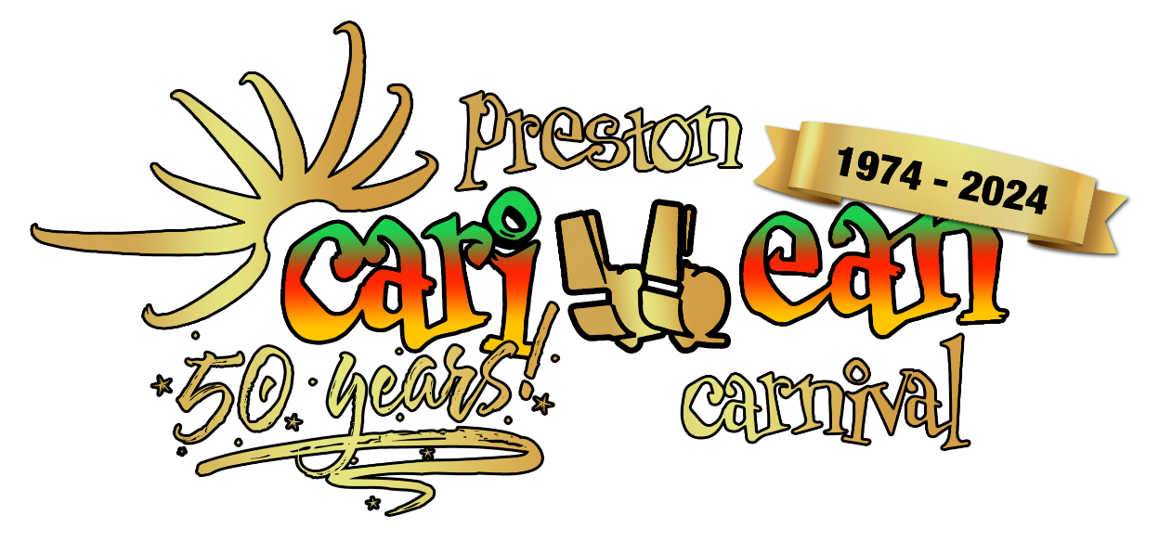

It’s Carnival time once again!

Firstly, thank you to everyone for your support in 2023, the procession and park event was huge success and we hope to make 2024 event bigger and better as it’s our 50th anniversary.
We are expanding our advertising opportunities and are producing an A5 sized publication for the event weekend of Saturday 25 and Sunday 26 May 2024. Circa 10,000 copies.
We are accepting Cheque or Bank payments as follows:
BY CHEQUE: Payable to Preston Caribbean Carnival Ltd and posted to: C/O The Treasurer, Preston Caribbean Carnival Ltd, Reg. Office: C/O Cotton Court Business Centre, Church Street, Preston. PR1 3BY
BY BANK PAYMENT: To: Preston Caribbean Carnival Ltd. Sort Code: 30 96 85 Account No: 29074060. Please quote business name as a reference.

2024 ADVERT PRICES
Inside Front Cover £250 󠄀
Inside Back Cover £250 󠄀
Full page £185 󠅟
Half page £100 󠅟

Important Information
If payment is made before 28 February 2024, a 10% discount can be applied. Please ask our representative if unsure.

Artwork must be emailed direct to our printer, details to be confirmed on booking and payment is required no later than Friday 8 March 2024.
Your payment will be taken following approval of artwork. Late payments may result in your advert being removed from the brochure.

Contact name: ………………………………………………………
Business name: …………………………………………………….
Address: ………………………………………………………….
………………………………………………………….
…………………………………………………………
Telephone: …………………………………………………………
Email: …………………………………………………………

